Week-3 Lab for Chapter 2
Task #1 Correcting Syntax Errors in Program
- Download the file Missingpart.java from folder Week-3
- Compile the source file, run the program, and observe the output. Some of the output is incorrect. You need to correct syntax errors before compiling the program.
Turn in the corrected Missingpart.java file.

Task #2 Correcting Logic Errors in Formulas
- Download the file Formulas.java from folder Week-3
- Compile the source file, run the program, and observe the output. Some of the output is incorrect. You need to correct logic errors in the average formula and the temperature conversion formula. The logic errors could be due to conversion between data types, order of operations, or formula problems. The necessary formulas are
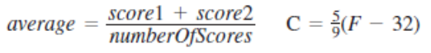
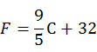

- Each time you make changes to the program code, you must save and compile again for the changes to take effect before running the program again.
- Make sure that the output makes sense before you continue. The average of 95 and 100 should be 97.5. And, 100 degrees Celsius equals 212 degrees Fahrenheit.

Task #3 Using the Scanner Class and Predefined Math Functions
- Use the file Formulas.java to finish this task.
- Add a line that prompts the user to enter the diameter of a sphere.
- Read in and store the number into a variable called diameter (you will need to declare any variables that you use).
- The diameter is twice as long as the radius, so calculate and store the radius in an appropriately named variable.
- The formula for the volume of a sphere is
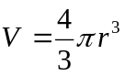
Convert the formula to Java and add a line which calculates and stores the value of volume in an appropriately named variable. Use Math.pow (參考課本70頁) to cube the radius. Use Math.PI for π in your program.
- Print your results to the screen with an appropriate message.
- Compile, debug, and run using the following test data.
Diameter | Volume (hand calculated) | Volume (resulting output)
2 | 4.18879
6 | 113.09724

